**Netaji Subhas University of Technology**

A STATE UNIVERSITY UNDER DELHI ACT 06 OF 2018, GOVT. OF NCT OF DELHI

Azad Hind Fauj Marg, Sector-3, Dwarka, New Delhi-110078



# LABORATORY FILE

# Computer Hardware and Software

Submitted By:

Name: Amogh Garg

Roll Number: 2020UCO1688

Branch: COE

Section: 3

**INDEX**

|  |  |
| --- | --- |
| **S. No.** | **Topic** |
| 1. | Introduction to Machine Learning libraries such as TinyML etc. |
| 2. | Introduction to automation and data visualisation using R Language. |
| 3. | Introduction to advances in data visualisation and analytics such as PowerBI etc. |
| 4. | Introduction of distributed databases for AI using Open Source frameworks like Apache Spark etc. |
| 5. | Introduction to DevOps for AI using any Open Source frameworks. |

**EXPERIMENT-1**

# **Create a Car Parking Prediction Model**

## **Description:**

In this, you need to find the Car Park Distance Prediction for Smart Vehicles. Most of the parking lots around the world make sure that the cars are parked in parallel. However, many people face difficulties when it comes to parallel parking, especially due to various assumptions one has to make regarding spatial arrangements. A machine learning algorithm needs to be implemented to calculate whether the car would be able to successfully park in the cavity or not, based on the distances measured by the sensor.

## **Approach:**

Since there is no relevant dataset on the internet, we have to create our own synthetic dataset. The synthetic dataset contains 3 columns. The description of features is as followed:

1. Car_Size : The length of the car in meters.
2. Parking_Space : The space available (in meters) for the car to be parked as detected by the sensor in the smart car.
3. Output : This is the output feature (binary). 0 indicates that car can not be parked in the available space. 1 indicates that car can be parked in the given space.

More relevant features can also be added in the dataset like whether the car supports power-cutting ability and other relevant specifications of the car in order to make accurate predictions. But for now to keep the model simple, we will be considering only Car_Size and Parking_Space as input features.

We will be creating a classifier from scratch using Tensorflow (Neural Networks using Keras) and then use TensorFlow Lite to convert the normal ML model into a Tiny ML Model (compressed form) which can then be embedded on devices with less memory like micro-controllers or egde devices. In our case this Tiny ML Model can be loaded into the micro-controller in the smart car which takes the input from the sensors installed in the car, processes the input and generates the relevant output

**DATASET :** <https://docs.google.com/spreadsheets/d/1rFzDI75nt0BiyPX1qJxdxVz6ZSkS-weV/edit?usp=share_link&ouid=103681875594479144076&rtpof=true&sd=true>

**CODE:**

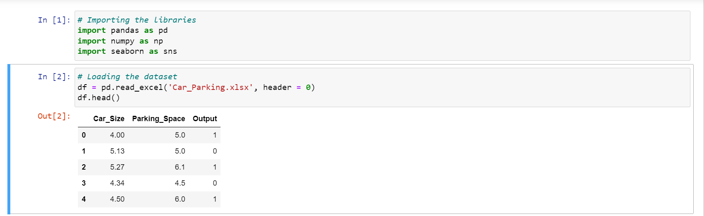

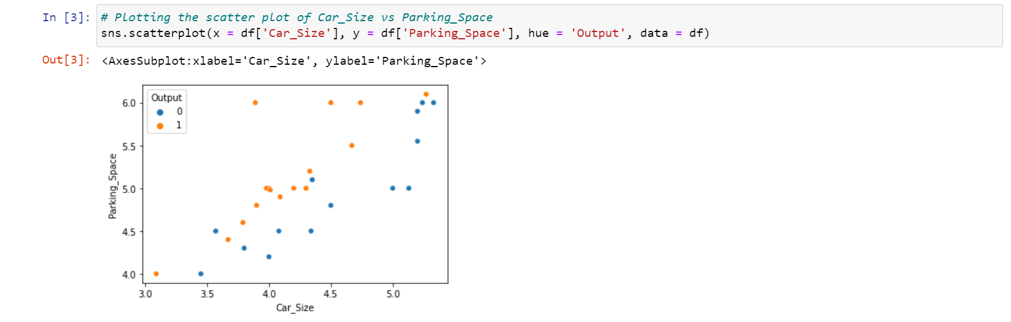

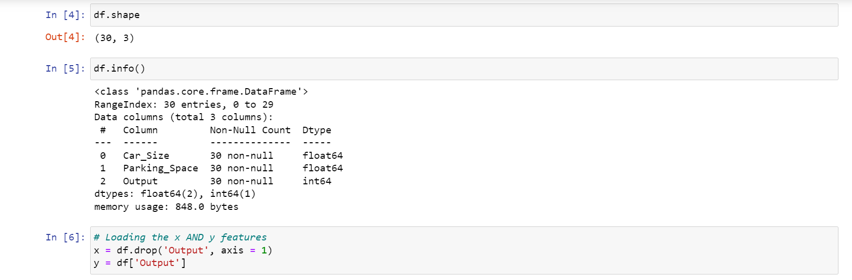

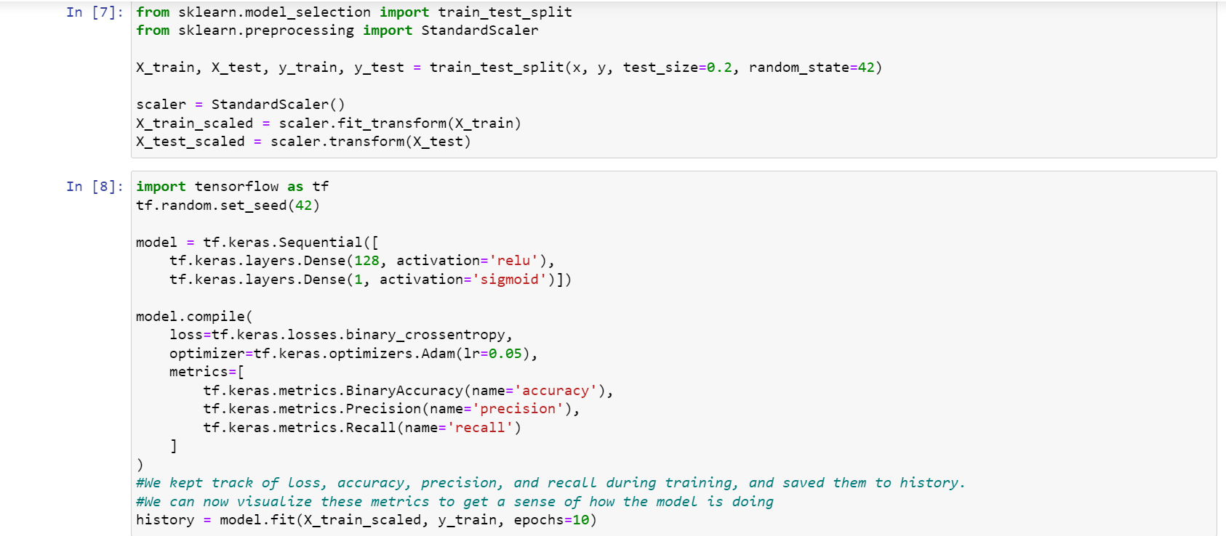

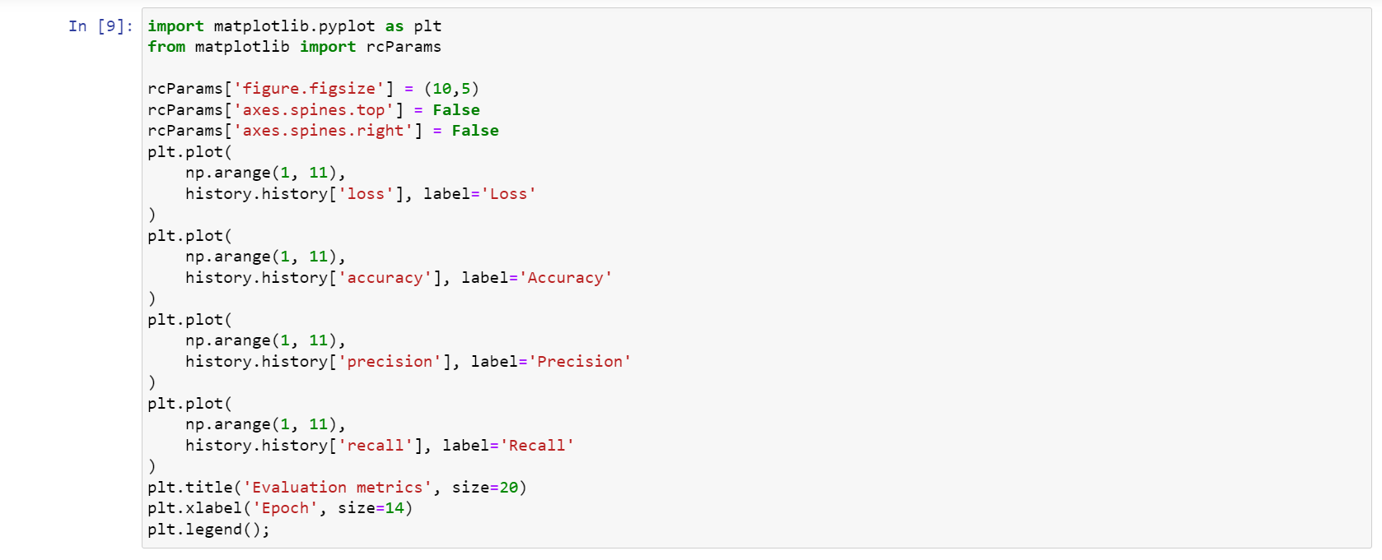

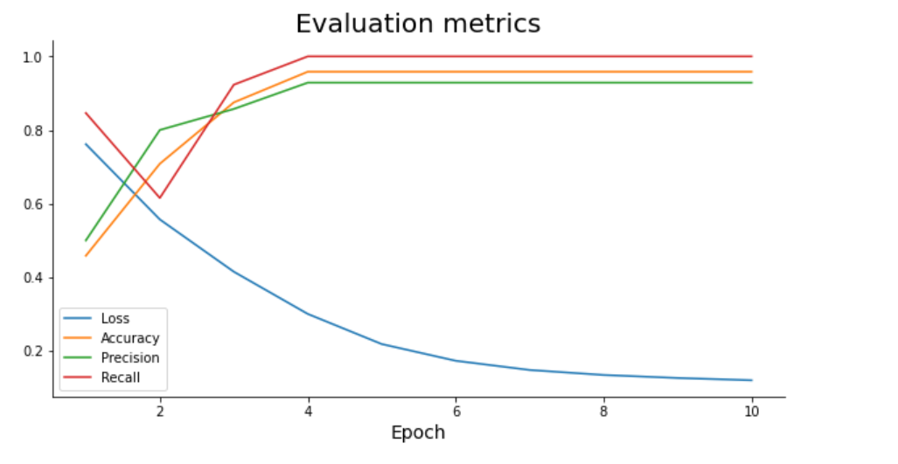

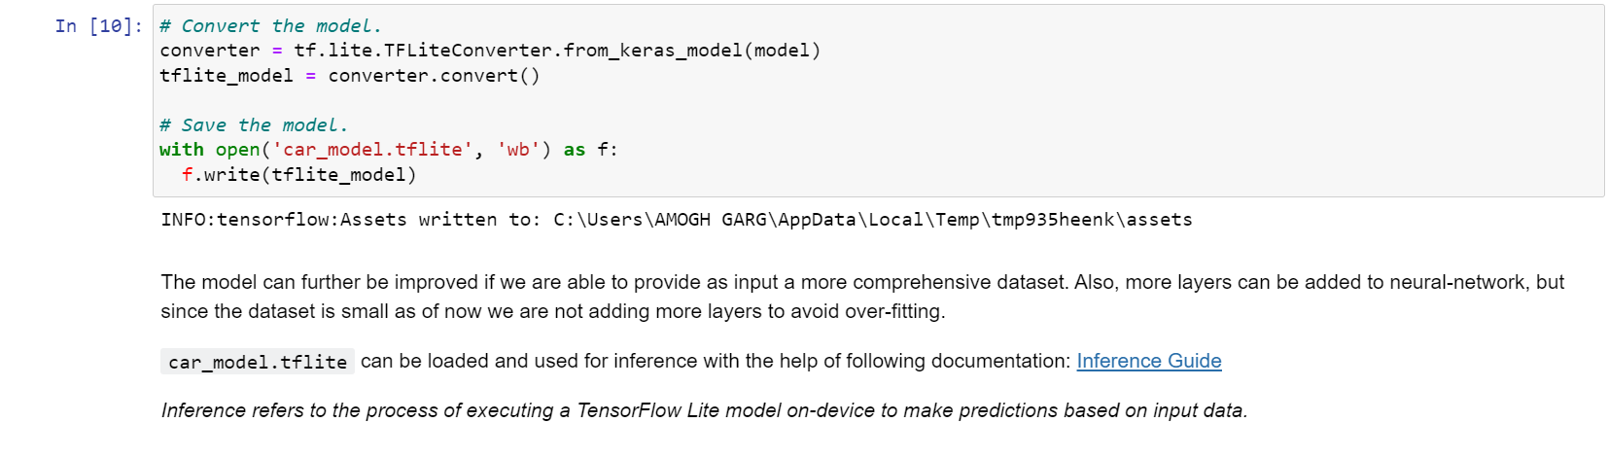

**EXPERIMENT-2**

**DESCRIPTION:** Data Visualization and Analytics using R Programming.

**DATASET:** [**https://drive.google.com/file/d/1C5kJ_FPTuFTvDF-xTbJ8h4IITCsNFVR9/view?usp=share_link**](https://drive.google.com/file/d/1C5kJ_FPTuFTvDF-xTbJ8h4IITCsNFVR9/view?usp=share_link)

**CODE:**

**# Importing the dataset**

dataset = read.csv('Data.csv')

**# Importing the dataset**

dataset = read.csv('Data.csv')

**# Taking care of missing data**

dataset$Age = ifelse(is.na(dataset$Age),

ave(dataset$Age, FUN = function(x) mean(x, na.rm = TRUE)),

dataset$Age)

dataset$Salary = ifelse(is.na(dataset$Salary),

ave(dataset$Salary, FUN = function(x) mean(x, na.rm = TRUE)),

dataset$Salary)

**# Importing the dataset**

dataset = read.csv('Data.csv')

**# Taking care of missing data**

dataset$Age = ifelse(is.na(dataset$Age),

ave(dataset$Age, FUN = function(x) mean(x, na.rm = TRUE)),

dataset$Age)

dataset$Salary = ifelse(is.na(dataset$Salary),

ave(dataset$Salary, FUN = function(x) mean(x, na.rm = TRUE)),

dataset$Salary)

**# Encoding categorical data**

dataset$Country = factor(dataset$Country,

levels = c('France', 'Spain', 'Germany'),

labels = c(1, 2, 3))

dataset$Purchased = factor(dataset$Purchased,

levels = c('No', 'Yes'),

labels = c(0, 1))

**# Splitting the dataset into the Training set and Test set**

**# install.packages('caTools')**

library(caTools)

set.seed(123)

split = sample.split(dataset$DependentVariable, SplitRatio = 0.8)

training_set = subset(dataset, split == TRUE)

test_set = subset(dataset, split == FALSE)

**# Feature Scaling**

training_set = scale(training_set)

test_set = scale(test_set)

**EXPERIMENT-3**

**DESCRIPTION:** Data Visualization using PowerBI.

**DATASET:** <https://www.kaggle.com/datasets/imdevskp/corona-virus-report?select=country_wise_latest.csv>

**POWER BI REPORT:**

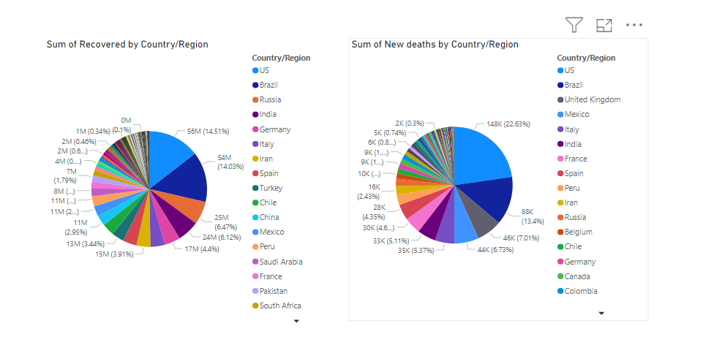

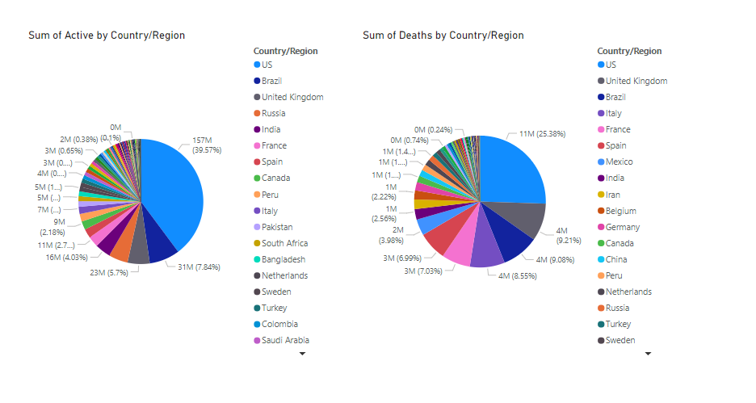

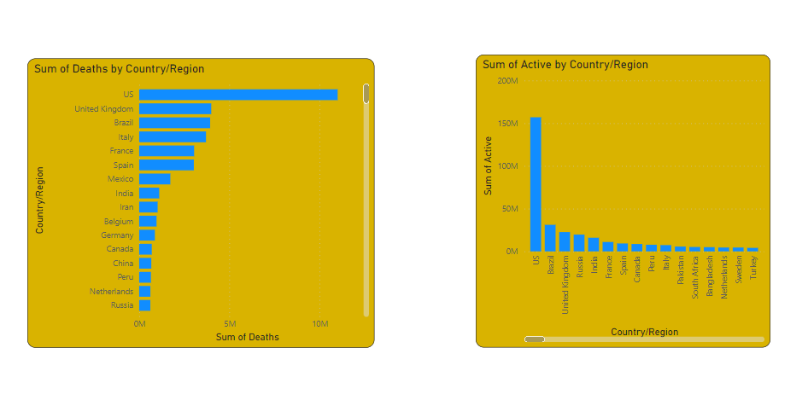

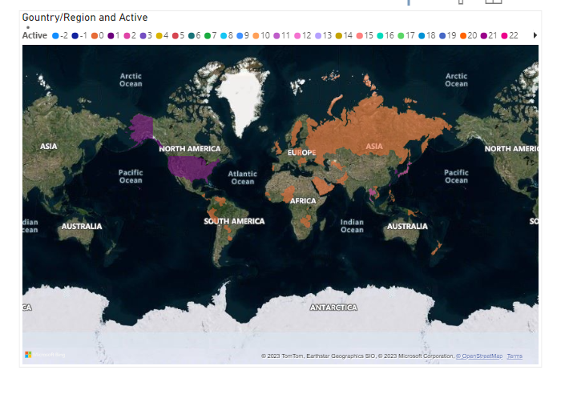

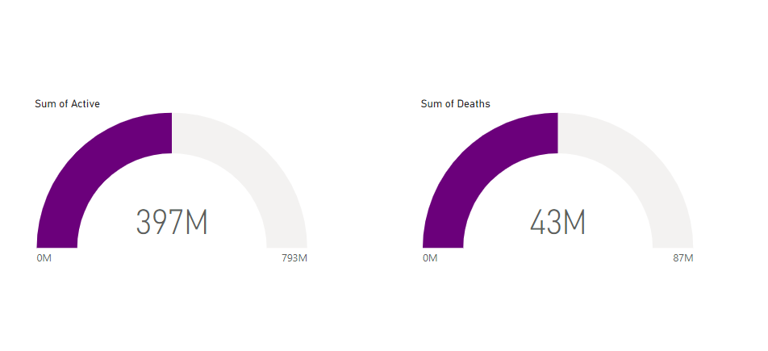

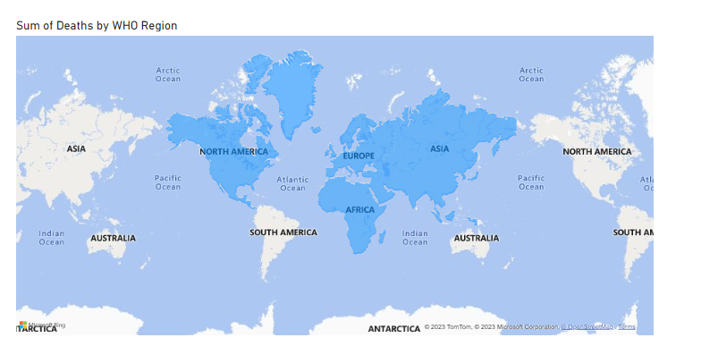

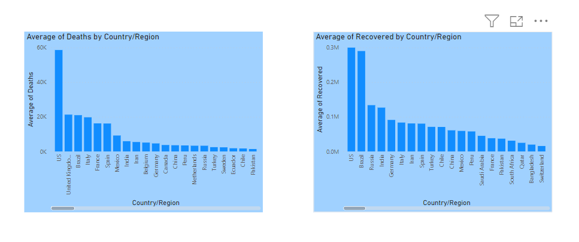

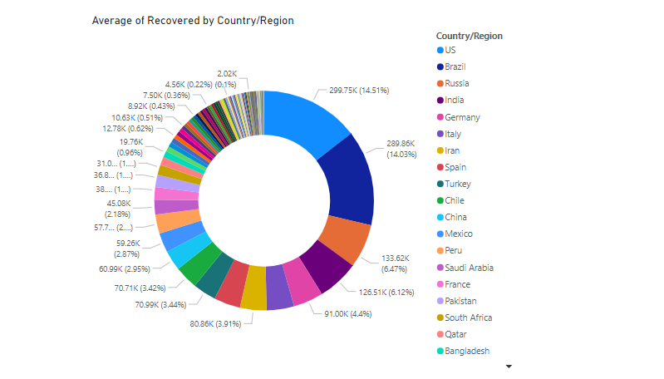

**EXPERIMENT-4**

**DESCRIPTION:** Create and manipulate database in spark  
- Install Spark in Google Collaboratory.  
- Use RDD  
- Use Dataframe  
- Implement linear regression using sparkMlib

**CODE AND OUTPUT:**

!apt-get install openjdk-8-jdk-headless -qq > /dev/null

!wget -q http://archive.apache.org/dist/spark/spark-3.1.1/spark-3.1.1-bin-hadoop3.2.tgz

!tar xf spark-3.1.1-bin-hadoop3.2.tgz

!pip install -q findspark

import os

os.environ["JAVA_HOME"] = "/usr/lib/jvm/java-8-openjdk-amd64"

os.environ["SPARK_HOME"] = "/content/spark-3.1.1-bin-hadoop3.2"

import findspark

findspark.init()

from pyspark.sql import SparkSession

spark = SparkSession.builder.master("local[*]").getOrCreate()

spark.conf.set("spark.sql.repl.eagerEval.enabled", True) # Property used to format output tables better

spark

# Load data from csv to a dataframe.

# header=True means the first row is a header

# sep=';' means the column are seperated using ''

df = spark.read.csv('cars.csv', header=True, sep=";")

df.show(5)

+--------------------+----+---------+------------+----------+------+------------+-----+------+

| Car| MPG|Cylinders|Displacement|Horsepower|Weight|Acceleration|Model|Origin|

+--------------------+----+---------+------------+----------+------+------------+-----+------+

|Chevrolet Chevell...|18.0| 8| 307.0| 130.0| 3504.| 12.0| 70| US|

| Buick Skylark 320|15.0| 8| 350.0| 165.0| 3693.| 11.5| 70| US|

| Plymouth Satellite|18.0| 8| 318.0| 150.0| 3436.| 11.0| 70| US|

| AMC Rebel SST|16.0| 8| 304.0| 150.0| 3433.| 12.0| 70| US|

| Ford Torino|17.0| 8| 302.0| 140.0| 3449.| 10.5| 70| US|

+--------------------+----+---------+------------+----------+------+------------+-----+------+

only showing top 5 rows

df = spark.read.csv('cars.csv', header=True, sep=";", inferSchema=True)

df.printSchema()

root

|-- Car: string (nullable = true)

|-- MPG: double (nullable = true)

|-- Cylinders: integer (nullable = true)

|-- Displacement: double (nullable = true)

|-- Horsepower: double (nullable = true)

|-- Weight: decimal(4,0) (nullable = true)

|-- Acceleration: double (nullable = true)

|-- Model: integer (nullable = true)

|-- Origin: string (nullable = true)

cars = spark.sparkContext.textFile('cars.csv')

print(cars.first())

cars_header = cars.first()

cars_rest = cars.filter(lambda line: line!=cars_header)

print(cars_rest.first())

Car;MPG;Cylinders;Displacement;Horsepower;Weight;Acceleration;Model;Origin

Chevrolet Chevelle Malibu;18.0;8;307.0;130.0;3504.;12.0;70;US

cars_rest.map(lambda line: line.split(";")).count()

406

# Car name is column  0

(cars_rest.filter(lambda line: line.split(";")[8]=='Europe').

 map(lambda line: (line.split(";")[0],

    line.split(";")[1],

    line.split(";")[2],

    line.split(";")[5],

    line.split(";")[8])).collect())

[('Citroen DS-21 Pallas', '0', '4', '3090.', 'Europe'), ('Volkswagen 1131 Deluxe Sedan', '26.0', '4', '1835.', 'Europe'), ('Peugeot 504', '25.0', '4', '2672.', 'Europe'), ('Audi 100 LS', '24.0', '4', '2430.', 'Europe'), ('Saab 99e', '25.0', '4', '2375.', 'Europe'), ('BMW 2002', '26.0', '4', '2234.', 'Europe'), ('Volkswagen Super Beetle 117', '0', '4', '1978.', 'Europe'), ('Opel 1900', '28.0', '4', '2123.', 'Europe'), ('Peugeot 304', '30.0', '4', '2074.', 'Europe'), ('Fiat 124B', '30.0', '4', '2065.', 'Europe'), ('Volkswagen Model 111', '27.0', '4', '1834.', 'Europe'), ('Volkswagen Type 3', '23.0', '4', '2254.', 'Europe'), ('Volvo 145e (sw)', '18.0', '4', '2933.', 'Europe'), ('Volkswagen 411 (sw)', '22.0', '4', '2511.', 'Europe'), ('Peugeot 504 (sw)', '21.0', '4', '2979.', 'Europe'), ('Renault 12 (sw)', '26.0', '4', '2189.', 'Europe'), ('Volkswagen Super Beetle', '26.0', '4', '1950.', 'Europe'), ('Fiat 124 Sport Coupe', '26.0', '4', '2265.', 'Europe'), ('Fiat 128', '29.0', '4', '1867.', 'Europe'), ('Opel Manta', '24.0', '4', '2158.', 'Europe'), ('Audi 100LS', '20.0', '4', '2582.', 'Europe'), ('Volvo 144ea', '19.0', '4', '2868.', 'Europe'), ('Saab 99le', '24.0', '4', '2660.', 'Europe'), ('Audi Fox', '29.0', '4', '2219.', 'Europe'), ('Volkswagen Dasher', '26.0', '4', '1963.', 'Europe'), ('Opel Manta', '26.0', '4', '2300.', 'Europe'), ('Fiat 128', '24.0', '4', '2108.', 'Europe'), ('Fiat 124 TC', '26.0', '4', '2246.', 'Europe'), ('Fiat x1.9', '31.0', '4', '2000.', 'Europe'), ('Volkswagen Dasher', '25.0', '4', '2223.', 'Europe'), ('Volkswagen Rabbit', '29.0', '4', '1937.', 'Europe'), ('Audi 100LS', '23.0', '4', '2694.', 'Europe'), ('Peugeot 504', '23.0', '4', '2957.', 'Europe'), ('Volvo 244DL', '22.0', '4', '2945.', 'Europe'), ('Saab 99LE', '25.0', '4', '2671.', 'Europe'), ('Fiat 131', '28.0', '4', '2464.', 'Europe'), ('Opel 1900', '25.0', '4', '2220.', 'Europe'), ('Renault 12tl', '27.0', '4', '2202.', 'Europe'), ('Volkswagen Rabbit', '29.0', '4', '1937.', 'Europe'), ('Volkswagen Rabbit', '29.5', '4', '1825.', 'Europe'), ('Volvo 245', '20.0', '4', '3150.', 'Europe'), ('Peugeot 504', '19.0', '4', '3270.', 'Europe'), ('Mercedes-Benz 280s', '16.5', '6', '3820.', 'Europe'), ('Renault 5 GTL', '36.0', '4', '1825.', 'Europe'), ('Volkswagen Rabbit Custom', '29.0', '4', '1940.', 'Europe'), ('Volkswagen Dasher', '30.5', '4', '2190.', 'Europe'), ('BMW 320i', '21.5', '4', '2600.', 'Europe'), ('Volkswagen Rabbit Custom Diesel', '43.1', '4', '1985.', 'Europe'), ('Audi 5000', '20.3', '5', '2830.', 'Europe'), ('Volvo 264gl', '17.0', '6', '3140.', 'Europe'), ('Saab 99gle', '21.6', '4', '2795.', 'Europe'), ('Peugeot 604sl', '16.2', '6', '3410.', 'Europe'), ('Volkswagen Scirocco', '31.5', '4', '1990.', 'Europe'), ('Volkswagen Rabbit Custom', '31.9', '4', '1925.', 'Europe'), ('Mercedes Benz 300d', '25.4', '5', '3530.', 'Europe'), ('Peugeot 504', '27.2', '4', '3190.', 'Europe'), ('Fiat Strada Custom', '37.3', '4', '2130.', 'Europe'), ('Volkswagen Rabbit', '41.5', '4', '2144.', 'Europe'), ('Audi 4000', '34.3', '4', '2188.', 'Europe'), ('Volkswagen Rabbit C (Diesel)', '44.3', '4', '2085.', 'Europe'), ('Volkswagen Dasher (diesel)', '43.4', '4', '2335.', 'Europe'), ('Audi 5000s (diesel)', '36.4', '5', '2950.', 'Europe'), ('Mercedes-Benz 240d', '30.0', '4', '3250.', 'Europe'), ('Renault Lecar Deluxe', '40.9', '4', '1835.', 'Europe'), ('Volkswagen Rabbit', '29.8', '4', '1845.', 'Europe'), ('Triumph TR7 Coupe', '35.0', '4', '2500.', 'Europe'), ('Volkswagen Jetta', '33.0', '4', '2190.', 'Europe'), ('Renault 18i', '34.5', '4', '2320.', 'Europe'), ('Peugeot 505s Turbo Diesel', '28.1', '4', '3230.', 'Europe'), ('Saab 900s', '0', '4', '2800.', 'Europe'), ('Volvo Diesel', '30.7', '6', '3160.', 'Europe'), ('Volkswagen Rabbit l', '36.0', '4', '1980.', 'Europe'), ('Volkswagen Pickup', '44.0', '4', '2130.', 'Europe')]

(cars_rest.filter(lambda line: line.split(";")[8] in ['Europe','Japan']).

 map(lambda line: (line.split(";")[0],

    line.split(";")[1],

    line.split(";")[2],

    line.split(";")[5],

    line.split(";")[8])).collect())

[('Citroen DS-21 Pallas', '0', '4', '3090.', 'Europe'), ('Toyota Corolla Mark ii', '24.0', '4', '2372.', 'Japan'), ('Datsun PL510', '27.0', '4', '2130.', 'Japan'), ('Volkswagen 1131 Deluxe Sedan', '26.0', '4', '1835.', 'Europe'), ('Peugeot 504', '25.0', '4', '2672.', 'Europe'), ('Audi 100 LS', '24.0', '4', '2430.', 'Europe'), ('Saab 99e', '25.0', '4', '2375.', 'Europe'), ('BMW 2002', '26.0', '4', '2234.', 'Europe'), ('Datsun PL510', '27.0', '4', '2130.', 'Japan'), ('Toyota Corolla', '25.0', '4', '2228.', 'Japan'), ('Volkswagen Super Beetle 117', '0', '4', '1978.', 'Europe'), ('Opel 1900', '28.0', '4', '2123.', 'Europe'), ('Peugeot 304', '30.0', '4', '2074.', 'Europe'), ('Fiat 124B', '30.0', '4', '2065.', 'Europe'), ('Toyota Corolla 1200', '31.0', '4', '1773.', 'Japan'), ('Datsun 1200', '35.0', '4', '1613.', 'Japan'), ('Volkswagen Model 111', '27.0', '4', '1834.', 'Europe'), ('Toyota Corolla Hardtop', '24.0', '4', '2278.', 'Japan'), ('Volkswagen Type 3', '23.0', '4', '2254.', 'Europe'), ('Mazda RX2 Coupe', '19.0', '3', '2330.', 'Japan'), ('Volvo 145e (sw)', '18.0', '4', '2933.', 'Europe'), ('Volkswagen 411 (sw)', '22.0', '4', '2511.', 'Europe'), ('Peugeot 504 (sw)', '21.0', '4', '2979.', 'Europe'), ('Renault 12 (sw)', '26.0', '4', '2189.', 'Europe'), ('Datsun 510 (sw)', '28.0', '4', '2288.', 'Japan'), ('Toyota Corolla Mark II (sw)', '23.0', '4', '2506.', 'Japan'), ('Toyota Corolla 1600 (sw)', '27.0', '4', '2100.', 'Japan'), ('Volkswagen Super Beetle', '26.0', '4', '1950.', 'Europe'), ('Toyota Camry', '20.0', '4', '2279.', 'Japan'), ('Datsun 610', '22.0', '4', '2379.', 'Japan'), ('Mazda RX3', '18.0', '3', '2124.', 'Japan'), ('Fiat 124 Sport Coupe', '26.0', '4', '2265.', 'Europe'), ('Fiat 128', '29.0', '4', '1867.', 'Europe'), ('Opel Manta', '24.0', '4', '2158.', 'Europe'), ('Audi 100LS', '20.0', '4', '2582.', 'Europe'), ('Volvo 144ea', '19.0', '4', '2868.', 'Europe'), ('Saab 99le', '24.0', '4', '2660.', 'Europe'), ('Toyota Mark II', '20.0', '6', '2807.', 'Japan'), ('Datsun B210', '31.0', '4', '1950.', 'Japan'), ('Toyota Corolla 1200', '32.0', '4', '1836.', 'Japan'), ('Audi Fox', '29.0', '4', '2219.', 'Europe'), ('Volkswagen Dasher', '26.0', '4', '1963.', 'Europe'), ('Opel Manta', '26.0', '4', '2300.', 'Europe'), ('Toyota Corolla', '31.0', '4', '1649.', 'Japan'), ('Datsun 710', '32.0', '4', '2003.', 'Japan'), ('Fiat 128', '24.0', '4', '2108.', 'Europe'), ('Fiat 124 TC', '26.0', '4', '2246.', 'Europe'), ('Honda Civic', '24.0', '4', '2489.', 'Japan'), ('Subaru', '26.0', '4', '2391.', 'Japan'), ('Fiat x1.9', '31.0', '4', '2000.', 'Europe'), ('Toyota Corolla', '29.0', '4', '2171.', 'Japan'), ('Toyota Corolla', '24.0', '4', '2702.', 'Japan'), ('Volkswagen Dasher', '25.0', '4', '2223.', 'Europe'), ('Datsun 710', '24.0', '4', '2545.', 'Japan'), ('Volkswagen Rabbit', '29.0', '4', '1937.', 'Europe'), ('Audi 100LS', '23.0', '4', '2694.', 'Europe'), ('Peugeot 504', '23.0', '4', '2957.', 'Europe'), ('Volvo 244DL', '22.0', '4', '2945.', 'Europe'), ('Saab 99LE', '25.0', '4', '2671.', 'Europe'), ('Honda Civic CVCC', '33.0', '4', '1795.', 'Japan'), ('Fiat 131', '28.0', '4', '2464.', 'Europe'), ('Opel 1900', '25.0', '4', '2220.', 'Europe'), ('Renault 12tl', '27.0', '4', '2202.', 'Europe'), ('Volkswagen Rabbit', '29.0', '4', '1937.', 'Europe'), ('Honda Civic', '33.0', '4', '1795.', 'Japan'), ('Volkswagen Rabbit', '29.5', '4', '1825.', 'Europe'), ('Datsun B-210', '32.0', '4', '1990.', 'Japan'), ('Toyota Corolla', '28.0', '4', '2155.', 'Japan'), ('Volvo 245', '20.0', '4', '3150.', 'Europe'), ('Peugeot 504', '19.0', '4', '3270.', 'Europe'), ('Toyota Mark II', '19.0', '6', '2930.', 'Japan'), ('Mercedes-Benz 280s', '16.5', '6', '3820.', 'Europe'), ('Honda Accord CVCC', '31.5', '4', '2045.', 'Japan'), ('Renault 5 GTL', '36.0', '4', '1825.', 'Europe'), ('Datsun F-10 Hatchback', '33.5', '4', '1945.', 'Japan'), ('Volkswagen Rabbit Custom', '29.0', '4', '1940.', 'Europe'), ('Toyota Corolla Liftback', '26.0', '4', '2265.', 'Japan'), ('Subaru DL', '30.0', '4', '1985.', 'Japan'), ('Volkswagen Dasher', '30.5', '4', '2190.', 'Europe'), ('Datsun 810', '22.0', '6', '2815.', 'Japan'), ('BMW 320i', '21.5', '4', '2600.', 'Europe'), ('Mazda RX-4', '21.5', '3', '2720.', 'Japan'), ('Volkswagen Rabbit Custom Diesel', '43.1', '4', '1985.', 'Europe'), ('Mazda GLC Deluxe', '32.8', '4', '1985.', 'Japan'), ('Datsun B210 GX', '39.4', '4', '2070.', 'Japan'), ('Honda Civic CVCC', '36.1', '4', '1800.', 'Japan'), ('Toyota Corolla', '27.5', '4', '2560.', 'Japan'), ('Datsun 510', '27.2', '4', '2300.', 'Japan'), ('Toyota Celica GT Liftback', '21.1', '4', '2515.', 'Japan'), ('Datsun 200-SX', '23.9', '4', '2405.', 'Japan'), ('Audi 5000', '20.3', '5', '2830.', 'Europe'), ('Volvo 264gl', '17.0', '6', '3140.', 'Europe'), ('Saab 99gle', '21.6', '4', '2795.', 'Europe'), ('Peugeot 604sl', '16.2', '6', '3410.', 'Europe'), ('Volkswagen Scirocco', '31.5', '4', '1990.', 'Europe'), ('Honda Accord LX', '29.5', '4', '2135.', 'Japan'), ('Volkswagen Rabbit Custom', '31.9', '4', '1925.', 'Europe'), ('Mazda GLC Deluxe', '34.1', '4', '1975.', 'Japan'), ('Mercedes Benz 300d', '25.4', '5', '3530.', 'Europe'), ('Peugeot 504', '27.2', '4', '3190.', 'Europe'), ('Datsun 210', '31.8', '4', '2020.', 'Japan'), ('Fiat Strada Custom', '37.3', '4', '2130.', 'Europe'), ('Volkswagen Rabbit', '41.5', '4', '2144.', 'Europe'), ('Toyota Corolla Tercel', '38.1', '4', '1968.', 'Japan'), ('Datsun 310', '37.2', '4', '2019.', 'Japan'), ('Audi 4000', '34.3', '4', '2188.', 'Europe'), ('Toyota Corolla Liftback', '29.8', '4', '2711.', 'Japan'), ('Mazda 626', '31.3', '4', '2542.', 'Japan'), ('Datsun 510 Hatchback', '37.0', '4', '2434.', 'Japan'), ('Toyota Corolla', '32.2', '4', '2265.', 'Japan'), ('Mazda GLC', '46.6', '4', '2110.', 'Japan'), ('Datsun 210', '40.8', '4', '2110.', 'Japan'), ('Volkswagen Rabbit C (Diesel)', '44.3', '4', '2085.', 'Europe'), ('Volkswagen Dasher (diesel)', '43.4', '4', '2335.', 'Europe'), ('Audi 5000s (diesel)', '36.4', '5', '2950.', 'Europe'), ('Mercedes-Benz 240d', '30.0', '4', '3250.', 'Europe'), ('Honda Civic 1500 gl', '44.6', '4', '1850.', 'Japan'), ('Renault Lecar Deluxe', '40.9', '4', '1835.', 'Europe'), ('Subaru DL', '33.8', '4', '2145.', 'Japan'), ('Volkswagen Rabbit', '29.8', '4', '1845.', 'Europe'), ('Datsun 280-ZX', '32.7', '6', '2910.', 'Japan'), ('Mazda RX-7 GS', '23.7', '3', '2420.', 'Japan'), ('Triumph TR7 Coupe', '35.0', '4', '2500.', 'Europe'), ('Honda Accord', '32.4', '4', '2290.', 'Japan'), ('Toyota Starlet', '39.1', '4', '1755.', 'Japan'), ('Honda Civic 1300', '35.1', '4', '1760.', 'Japan'), ('Subaru', '32.3', '4', '2065.', 'Japan'), ('Datsun 210 MPG', '37.0', '4', '1975.', 'Japan'), ('Toyota Tercel', '37.7', '4', '2050.', 'Japan'), ('Mazda GLC 4', '34.1', '4', '1985.', 'Japan'), ('Volkswagen Jetta', '33.0', '4', '2190.', 'Europe'), ('Renault 18i', '34.5', '4', '2320.', 'Europe'), ('Honda Prelude', '33.7', '4', '2210.', 'Japan'), ('Toyota Corolla', '32.4', '4', '2350.', 'Japan'), ('Datsun 200SX', '32.9', '4', '2615.', 'Japan'), ('Mazda 626', '31.6', '4', '2635.', 'Japan'), ('Peugeot 505s Turbo Diesel', '28.1', '4', '3230.', 'Europe'), ('Saab 900s', '0', '4', '2800.', 'Europe'), ('Volvo Diesel', '30.7', '6', '3160.', 'Europe'), ('Toyota Cressida', '25.4', '6', '2900.', 'Japan'), ('Datsun 810 Maxima', '24.2', '6', '2930.', 'Japan'), ('Volkswagen Rabbit l', '36.0', '4', '1980.', 'Europe'), ('Mazda GLC Custom l', '37.0', '4', '2025.', 'Japan'), ('Mazda GLC Custom', '31.0', '4', '1970.', 'Japan'), ('Nissan Stanza XE', '36.0', '4', '2160.', 'Japan'), ('Honda Accord', '36.0', '4', '2205.', 'Japan'), ('Toyota Corolla', '34.0', '4', '2245', 'Japan'), ('Honda Civic', '38.0', '4', '1965.', 'Japan'), ('Honda Civic (auto)', '32.0', '4', '1965.', 'Japan'), ('Datsun 310 GX', '38.0', '4', '1995.', 'Japan'), ('Toyota Celica GT', '32.0', '4', '2665.', 'Japan'), ('Volkswagen Pickup', '44.0', '4', '2130.', 'Europe')]

**Implementation of Linear Regression:**

df = spark.read.csv("/databricks-datasets/Rdatasets/data-001/csv/ggplot2/diamonds.csv", header="true", inferSchema="true")  
display(df)

from pyspark.ml import Pipeline  
from pyspark.ml.feature import StringIndexer, OneHotEncoder  
cat_cols= ["cut", "color", "clarity"]  
stages = [] # Stages in Pipeline  
  
for c in cat_cols:  
 stringIndexer = StringIndexer(inputCol=c, outputCol=c + "_index")  
 encoder = OneHotEncoder(inputCols=[stringIndexer.getOutputCol()], \  
 outputCols=[c + "_vec"])   
 stages += [stringIndexer, encoder] # Stages will be run later on

from pyspark.ml.feature import VectorAssembler  
  
# Transform all features into a vector  
num_cols = ["carat", "depth", "table", "x", "y", "z"]  
assemblerInputs = [c + "_vec" for c in cat_cols] + num_cols  
assembler = VectorAssembler(inputCols=assemblerInputs, outputCol="features")  
stages += [assembler]  
  
# Create pipeline and use on dataset  
pipeline = Pipeline(stages=stages)  
df = pipeline.fit(df).transform(df)

train, test = df.randomSplit([0.90, 0.1], seed=123)  
print('Train dataset count:', train.count())  
print('Test dataset count:', test.count())

from pyspark.ml.feature import StandardScaler  
  
# Fit scaler to train dataset  
scaler = StandardScaler().setInputCol('features') \  
 .setOutputCol('scaled_features')  
scaler_model = scaler.fit(train)  
  
# Scale train and test features  
train = scaler_model.transform(train)  
test = scaler_model.transform(test)

from pyspark.ml.regression import LinearRegression  
  
lr = LinearRegression(featuresCol='scaled_features', labelCol='price')  
lr_model = lr.fit(train)

train_predictions = lr_model.transform(train)  
test_predictions = lr_model.transform(test)

from pyspark.ml.evaluation import RegressionEvaluator  
  
evaluator = RegressionEvaluator(predictionCol="prediction", \  
 labelCol="price", metricName="r2")  
  
print("Train R2:", evaluator.evaluate(train_predictions))  
print("Test R2:", evaluator.evaluate(test_predictions))

**EXPERIMENT-5**

**DESCRIPTION:** MLops using Heroku and Github actions.  
MLops in Text Classification  
Step 1. Dataset and Preprocessing  
Step 2. Encoding and Machine Learning Model  
Step 3. Deployment on Heroku  
Step 4: Incorporating GitHub actions

**GITHUB LINK:** [miguelfzafra/Latest-News-Classifier: Master in Data Science Final Project (github.com)](https://github.com/miguelfzafra/Latest-News-Classifier)

**APPROACH:**

The whole process of the development of this project has been divided into three different posts:

* Classification model training ([link](https://towardsdatascience.com/text-classification-in-python-dd95d264c802))
* News articles web scraping ([link](https://towardsdatascience.com/web-scraping-news-articles-in-python-9dd605799558))
* App creation and deployment (this post)

**HEROKU DEPLOYMENT:**

Steps to be followed to deploy on Heroku:

# after signing in to Heroku and opening the anaconda prompt  
# we create a new folder  
$ mkdir dash-app-lnclass  
$ cd dash-app-lnclass# initialize the folder with git  
$ git init

After that, we create an environment file (environment.yml) in which we will indicate the dependencies we are going to need:

name: dash_app_lnclass #Environment name  
dependencies:  
 - python=3.6  
 - pip:  
 - dash  
 - dash-renderer  
 - dash-core-components  
 - dash-html-components  
 - dash-table  
 - plotly  
 - gunicorn # for app deployment  
 - nltk  
 - scikit-learn  
 - beautifulsoup4  
 - requests  
 - pandas  
 - numpy  
 - lxml

And activate the environment:

$ conda env create  
$ activate dash_app_lnclass

Then, we initialize the folder with app.py, requirements.txt and a Procfile:

# the procfile must contain the following line of code  
web: gunicorn app:server# to create the requirements.txt file, we run the following:  
$ pip freeze > requirements.txt

Finally, we initialize Heroku, add the files to Git and deploy:

$ heroku create lnclass # change my-dash-app to a unique name  
$ git add . # add all files to git  
$ git commit -m 'Comment'  
$ git push heroku master # deploy code to heroku  
$ heroku ps:scale web=1 # run the app with a 1 heroku "dyno"

**DEPLOYMENT LINK:** [Dash (latestnewsclassifier.herokuapp.com)](https://latestnewsclassifier.herokuapp.com/)

**OUTPUT SCREENSHOT:**

